**DevOps Lab 1: Introduction to DevOps Tools and Setup**

**Objective**

* Familiarize students with the software tools used in DevOps.
* Install and configure essential DevOps tools on Ubuntu.
* Understand the purpose and technical details of each tool.

**What is Development Operations?**

DevOps is a comprehensive approach that combines software development (Dev) and IT operations (Ops) to accelerate the delivery of high-quality software. Agile methodologies are leveraged in the software development lifecycle. Prototypes are developed and released frequently and delivered to the customer for feedback. The feedback is incorporated and another prototype is developed.

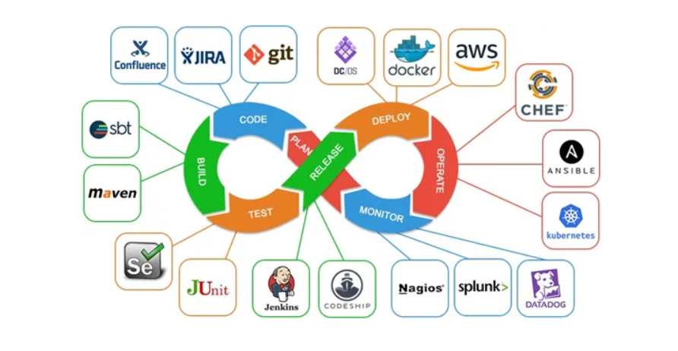

**Tools Overview**

Below is a list of software tools categorized by their purpose in DevOps. Both open-source and paid options are provided.

The following are the core Principles of Development Operation and tools related to each step of SDLC

**1. Version Control System (VCS)**

* **Purpose**: Manage and track changes to code.
* **Open Source**: Git
* **Paid Alternatives**: GitHub (free for public repos, paid for private), GitLab (free and paid tiers), Bitbucket (free and paid tiers).

**2. Continuous Integration/Continuous Deployment (CI/CD)**

* **Purpose**: Automate testing and deployment of code.
* **Open Source**: Jenkins, GitLab CI/CD, ArgoCD.
* **Paid Alternatives**: CircleCI, Travis CI, AWS CodePipeline.

**3. Containerization**

* **Purpose**: Package applications and dependencies into containers.
* **Open Source**: Docker, Podman.
* **Paid Alternatives**: Docker Hub (free and paid tiers), Red Hat OpenShift.

**4. Container Orchestration**

* **Purpose**: Manage and scale containerized applications.
* **Open Source**: Kubernetes, Docker Swarm.
* **Paid Alternatives**: Amazon EKS, Google GKE, Azure AKS.

**5. Infrastructure as Code (IaC)**

* **Purpose**: Automate infrastructure provisioning.
* **Open Source**: Terraform, Ansible, Pulumi.
* **Paid Alternatives**: AWS CloudFormation, Azure Resource Manager.

**6. Monitoring and Logging**

* **Purpose**: Monitor application performance and log errors.
* **Open Source**: Prometheus, Grafana, ELK Stack (Elasticsearch, Logstash, Kibana).
* **Paid Alternatives**: Datadog, New Relic, Splunk.

**7. Collaboration and Project Management**

* **Purpose**: Track tasks, issues, and collaborate with teams.
* **Open Source**: Taiga, OpenProject.
* **Paid Alternatives**: Jira, Trello, Asana.

**\*\*\*\*\*\*\*\*\*\*\*\*\*\*\*\*\*\*\*\*\*\*\*\*\*\*\*\*\*\*\*\*\*\*\*\*\*\*\*\*\*\*\*\*\*\*\*\*\*\*\*\*\*\*\*\*\*\*\*\*\*\*\*\*\*\*\*\*\*\*\*\*\*\*\*\*\*\*\*\*\*\*\*\*\***

Lab Tasks

* Step 1: Update Ubuntu
* Before installing any software, ensure your system is up to date

**sudo apt update && sudo apt upgrade -y**

* Step 2: Install Git

Git is essential for version control

**sudo apt install git -y**

**git --version**

* Step 3: Install Docker

Docker is used for containerization

**sudo apt install docker.io -y**

**sudo systemctl start docker**

**sudo systemctl enable docker**

**docker --version**

* Step 4: Install Kubernetes (Minikube)

Minikub is a lightweight Kubernetes implementing for learning.

**curl -LO https://storage.googleapis.com/minikube/releases/latest/minikube-linux-amd64**

**sudo install minikube-linux-amd64 /usr/local/bin/minikube**

**minikube start**

* Step 5: Install Terraform

Terraform is used for infrastructure as Code (IaC)

**sudo apt install terraform -y**

**terraform --version**

* Step 6: Install Jenkins

Jenkins is popular CI/CD tool

**sudo apt install openjdk-11-jdk -y**

**wget -q -O - https://pkg.jenkins.io/debian/jenkins.io.key | sudo apt-key add -**

**sudo sh -c 'echo deb http://pkg.jenkins.io/debian-stable binary/ > /etc/apt/sources.list.d/jenkins.list'**

**sudo apt update**

**sudo apt install jenkins -y**

**sudo systemctl start jenkins**

**sudo systemctl enable jenkins**

* Access Jenkins: Open browser and go to <https://localhost:8080>
* Step 7: Install prometheus and Grafana

Prometheus is used for monitoring, and Grafana is used for visualization

# Install Prometheus

**wget https://github.com/prometheus/prometheus/releases/download/v2.30.3/prometheus-2.30.3.linux-amd64.tar.gz**

**tar xvfz prometheus-2.30.3.linux-amd64.tar.gz**

**cd prometheus-2.30.3.linux-amd64**

**./prometheus &**

**# Install Grafana**

**sudo apt-get install -y apt-transport-https**

**sudo apt-get install -y software-properties-common wget**

**wget -q -O - https://packages.grafana.com/gpg.key | sudo apt-key add -**

**echo "deb https://packages.grafana.com/oss/deb stable main" | sudo tee -a /etc/apt/sources.list.d/grafana.list**

**sudo apt-get update**

**sudo apt-get install grafana -y**

**sudo systemctl start grafana-server**

**sudo systemctl enable grafana-server**

* Access Grafana-server: Open Browser and go to http://localhost:3000